1. Logon

Make sure that your browser locale is set according to the language the presentation is given.

Single Sing on for Cloud CPQ Express and C4C is set up. Use

<https://my318235-sso.crm.ondemand.com/> and login as

Sales Representative: DESALESREP01, Welcome1.

After that you may switch to responsive UI:

<https://my318235-sso.crm.ondemand.com/sap/ap/ui/repository/SAP_UI/HTML5/newclient.html>

1. Create Quote in C4C

Navigate to Sales – Sales Quotes and create new quote using `Sales Unit US` and e.g. account ‘Bluedrive’ 10004. Define payment terms.

Make sure to delete all products that are automatically added in products section.

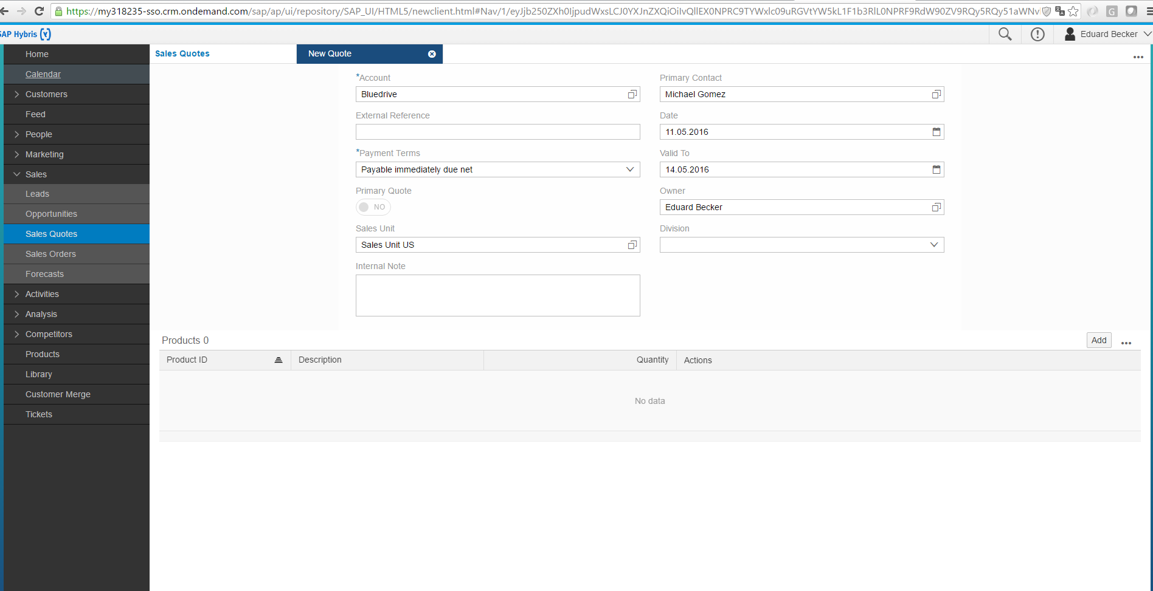

Save and open quote.

1. Open Cloud CPQ Express and configure quote

Select `Cloud CPQ Express` tab on quote level to add CPQ view to quote. This will open CPQ embedded as HTML-Mashup.

Add product(s) to quote:

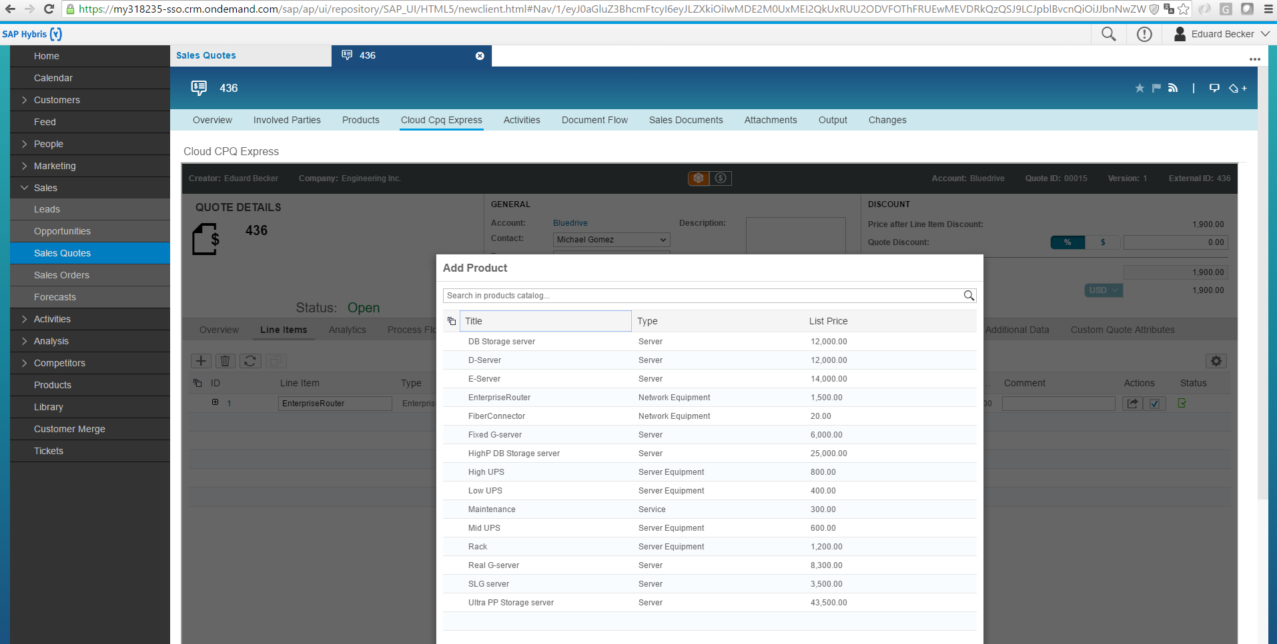

The list of products includes configurable and non-configurable parts. Select e.g. EnterpriseRouter for a configurable product.

Generally, the list of products and prices can be based on:

* Products and prices defined in Cloud CPQ Express,
* Material master from ERP and external pricing call/simulation,
* Configuration and pricing using SSC (Solution Sales Configuration).

Click on item ID to start product configuration:

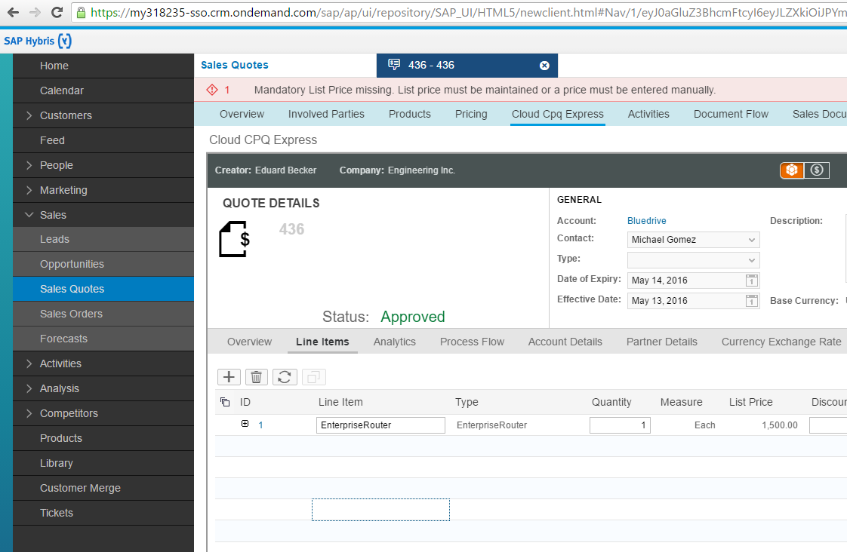

Make sure to define all mandatory attributes to get into status green for a complete product configuration:

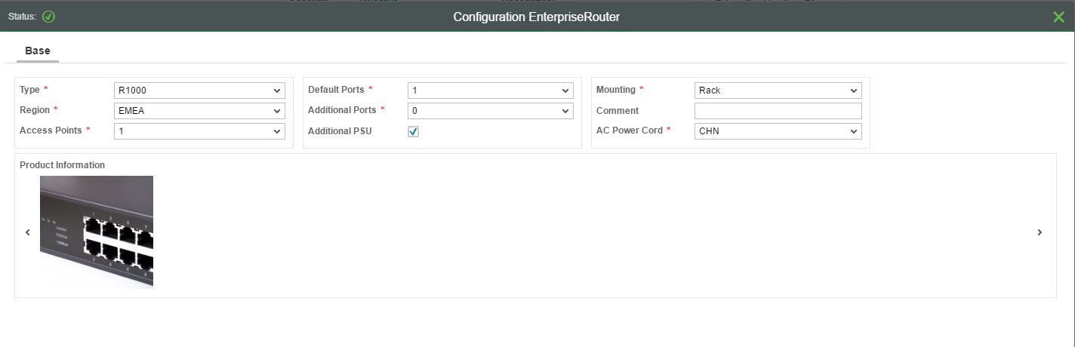

Configuration for root material controls sales bill-of-material for that item:

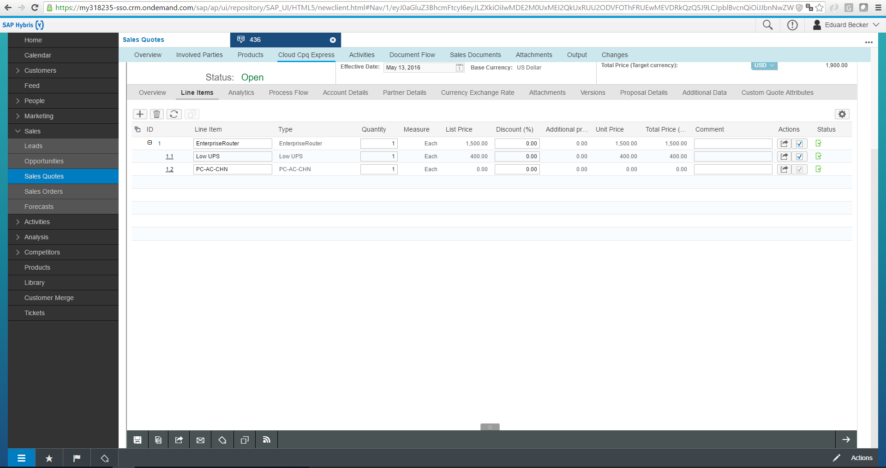

Switch to pricing details view to view and maintain price conditions.

Please note: Discount > 20 % requires Sales Manager approval (hence, you would need to logon as Sales Manager to approve the discount. Rather keep discount below 20% in your demo.)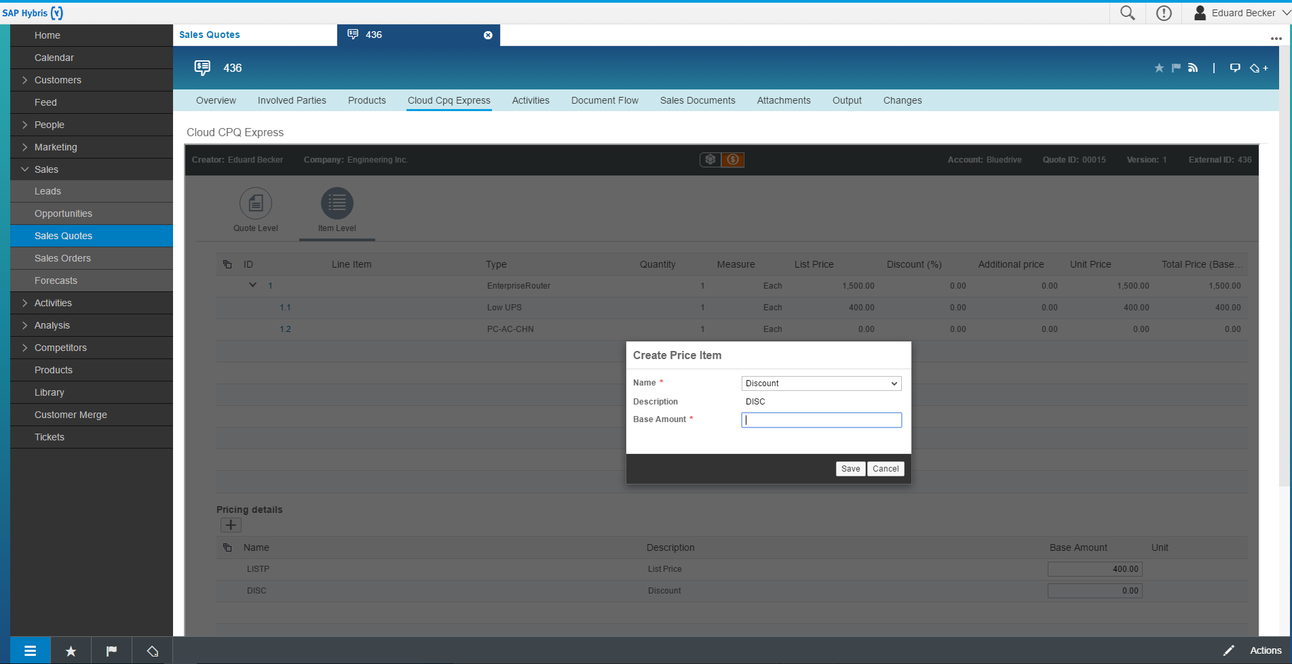

Make sure to save quote in Cloud CPQ Express. A pdf proposal document can be downloaded

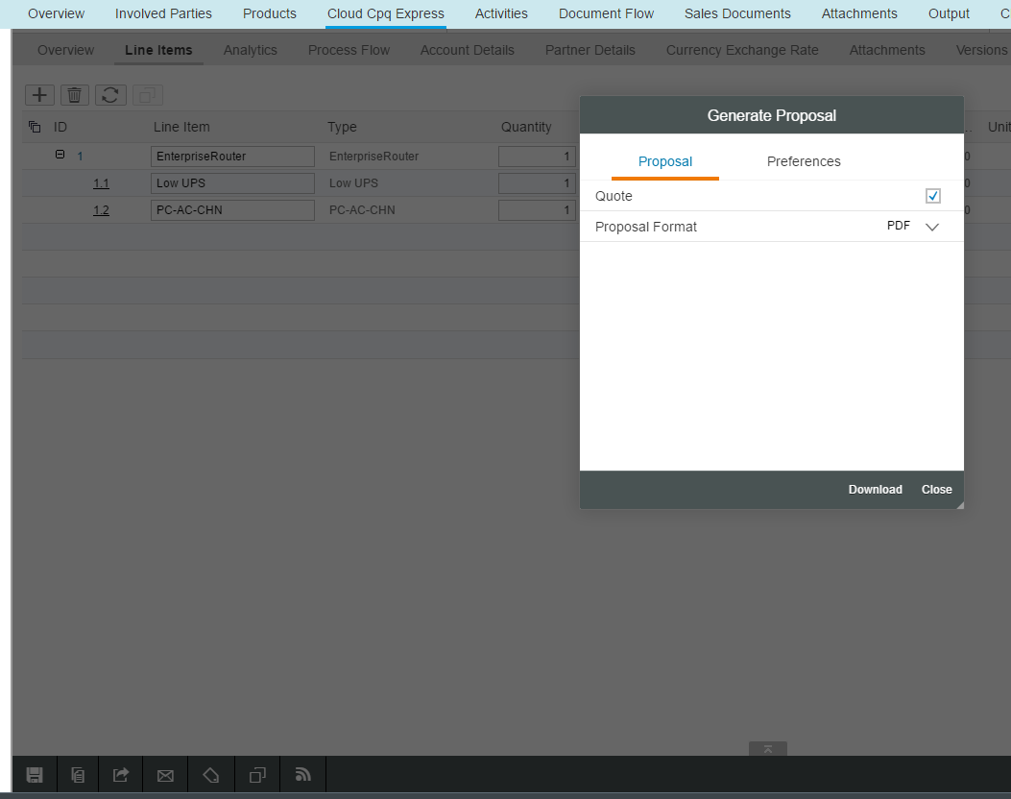

1. Update and show quote details in C4C

Use export button to sync quote details to C4C:



Show updated quote in Cloud for Customer (e.g. separate browser tab):

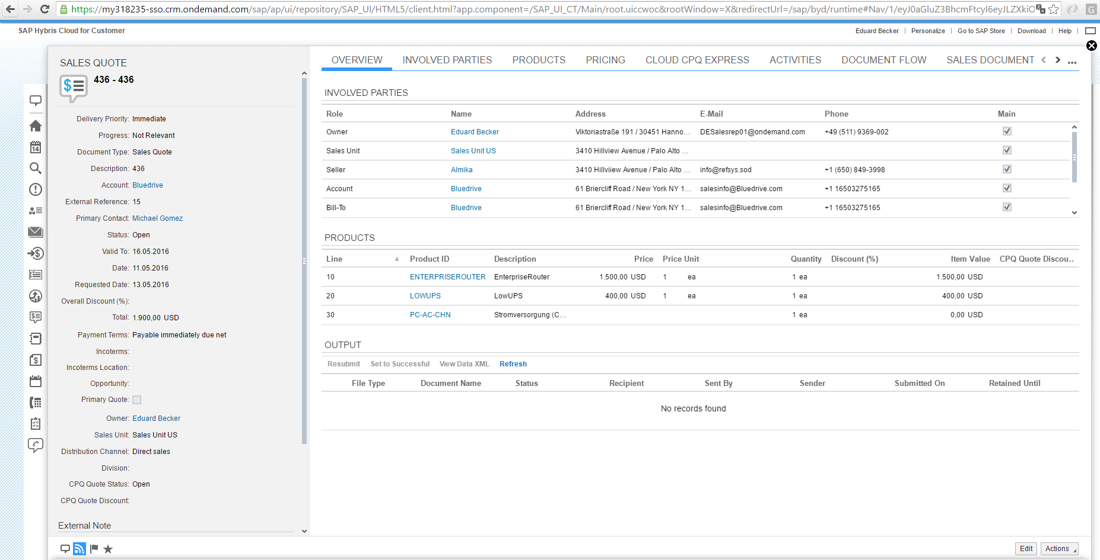

Proposal document is attached to C4C quote:

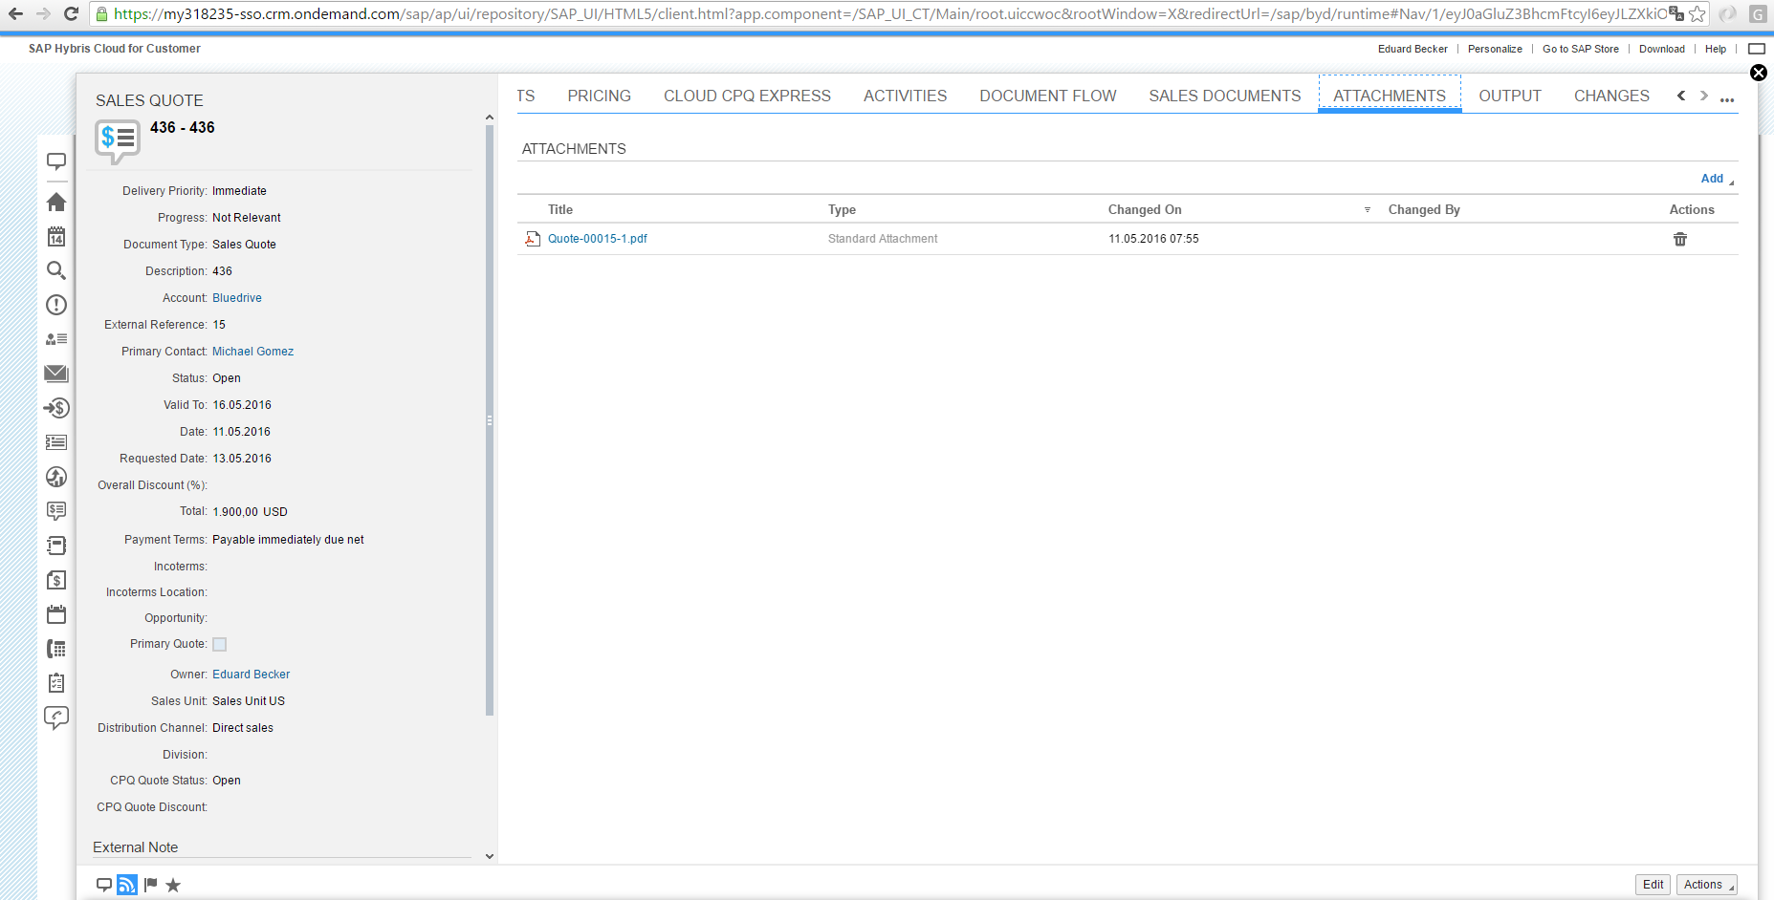

1. Submit quote for approval

Complete quote editing and click `submit`.



Quote status will change to `completed` if approval is required or `approved` if not.

An approval by Sales Manager is required if a line item discount exceeds 20%. CPQ process flow will visualize approval gates.

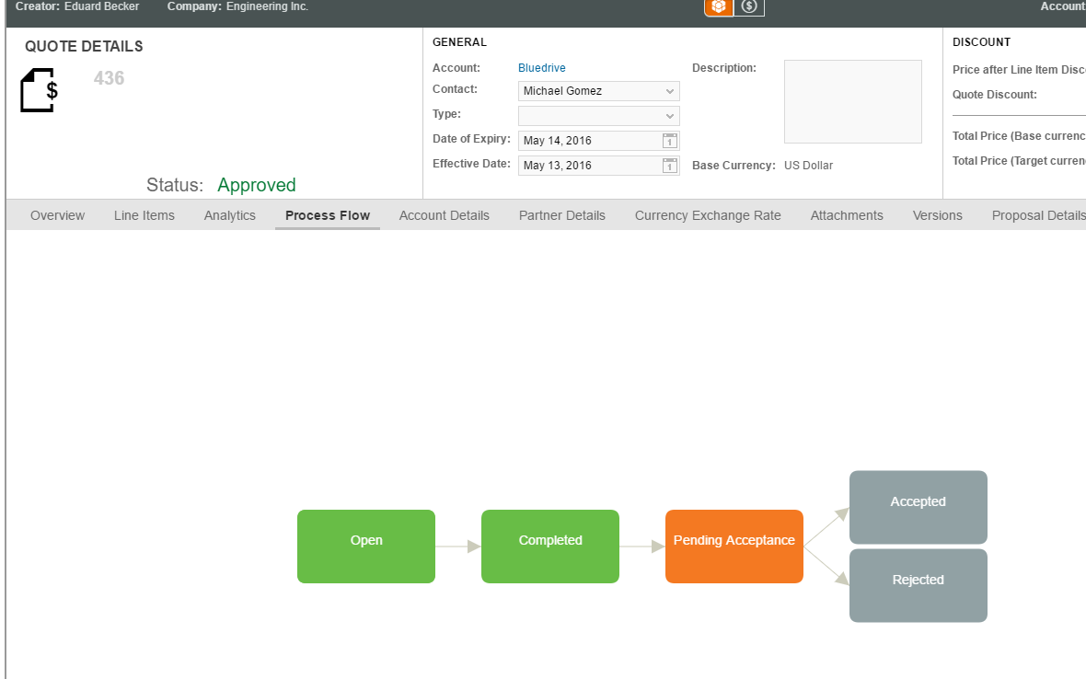

If an approval is required, log in as DESALESMAN, Welcome1 at <https://my318235-sso.crm.ondemand.com/>, open quote and accept.

E-mail notifications for e.g. pending quote approval are deactivated for this demo.

1. Accept quote

Mime customer acceptance and put quote into status ‘accepted’.



Hereafter, normally a sales document can be created in SAP ERP:

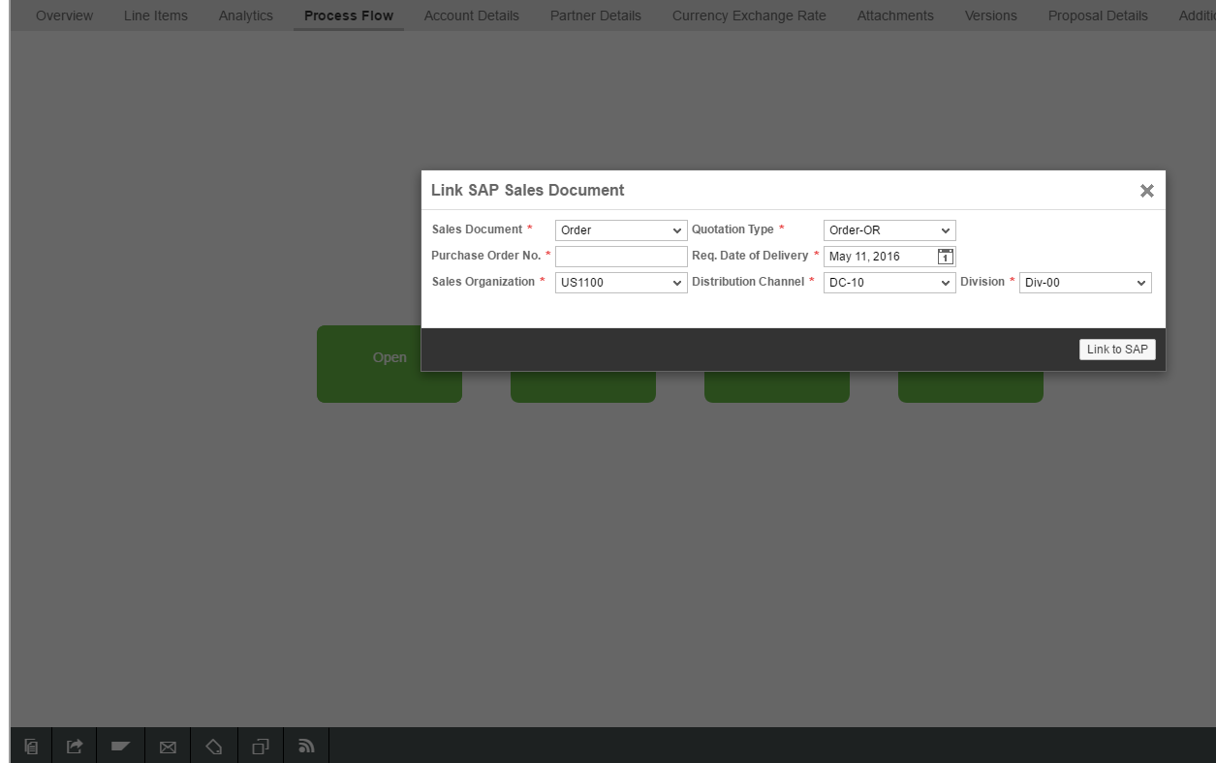

As there is no ERP back-end connection established in the case at hand, this operation will fail but you can show that function in your demo to emphasize the integration into the backend ERP.

End of the demo.

In case there are any further questions, please don´t hesitate to contact the In Mind team:

Markus Schoierer - Sales Director (DACH)

fon +49 89 20 500 85-341

mail [markus.schoierer@inmindcloud.com](mailto:markus.schoierer@inmindcloud.com)

web [www.inmindcloud.com](http://www.inmindcloud.com/)

Friedrich Teucher - Customer Success Manager  
fon +49 341 355 21313

mail [friedrich.teucher@inmindcloud.com](mailto:friedrich.teucher@inmindcloud.com)

Sabine Kempe – Marketing Director

fon: +65 6635 1723

mail sabine.kempe@inmindcloud.com